**CS560 Fall 2018 Project**

**Topic: Social Media**

**Description of Social Media Chat**

The Social Media Chat application will provide the user a communication platform to exchange messages and images. The user will also be able to make video calls and will have an option to encrypt.

**Actors**

3 types of User

* Regular User
  + The regular user can use most of chat function: chat, chat room, video
* Premium User
  + The premium user can chat with other premium user via using encrypt messages.
* Admin User
  + The admin user can control all the things.

**Functional Requirements (Have to)**

1. Register with the application.
   1. Have a login interface which has username, password, login, create an account and forgotten password.
2. Add/ Accept/ Delete friend requests.
   1. A User can use email or account to find a member and add him/her to be a friend.
   2. Your friend can click a button to accepts your request.
   3. A User can click a button to delete a friend.
3. Establish one to one chat.
4. Send /receive images.
   1. Click an icon to upload an image file.
5. Make one to one video calls.
6. Translate messages from one language to another.

**Functional Requirements (Nice to have)**

1. Make video conference calls.
   1. Initiate a video chat session that will be alive until the owner closes the session.
2. Send/ Receive Audio Messages.
3. View chat history.
4. Enable an option that will allow the premium user to encrypt the messages.
   1. Premium user can enable encrypt the messages function via click a button.

**Non-Functional Requirements**

1. Compatibility
   1. This must be a cross platform application.
2. Reliability
   1. Reliability through database mirroring

**User requirements**

1. The software should provide a good platform for all users chat with their friends. If the user is primary user, the user can send the encrypt messages to another primary user.

**System requirements**

1. Only registered users can use the applications.
2. User cannot chat with other who is not on his/her friend list.
3. Only premium members can use the encryption option.

**Technologies used**

* Front End: Python
* Backend: C#
* Database: SQL Server
* Server: Run on Windows OS

**Module Diagram**

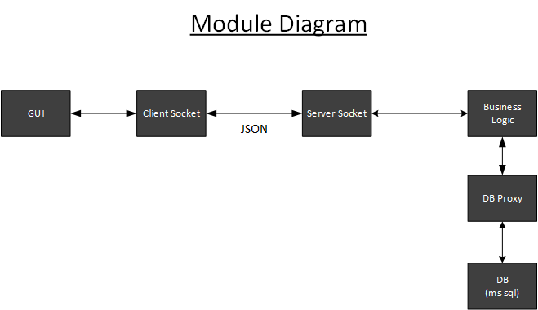

**Sequence Diagram**

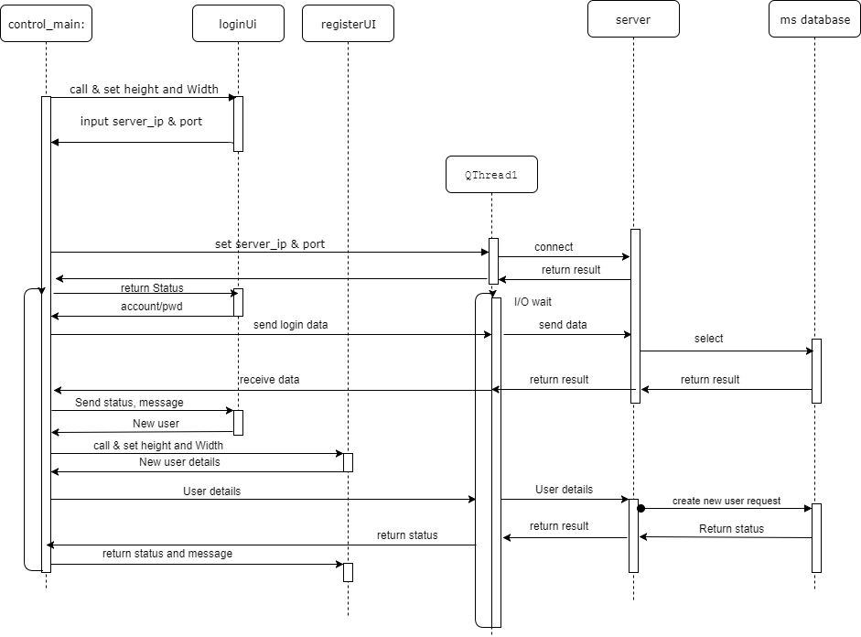

**Class Diagram**

**For server site**

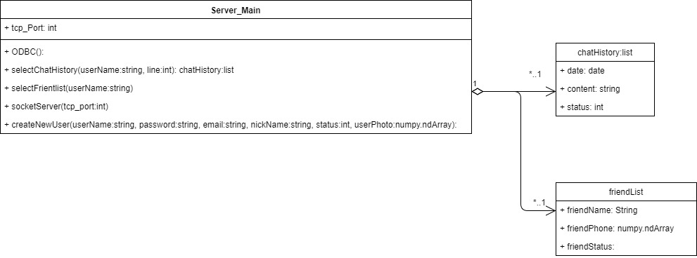

**Foe client side**